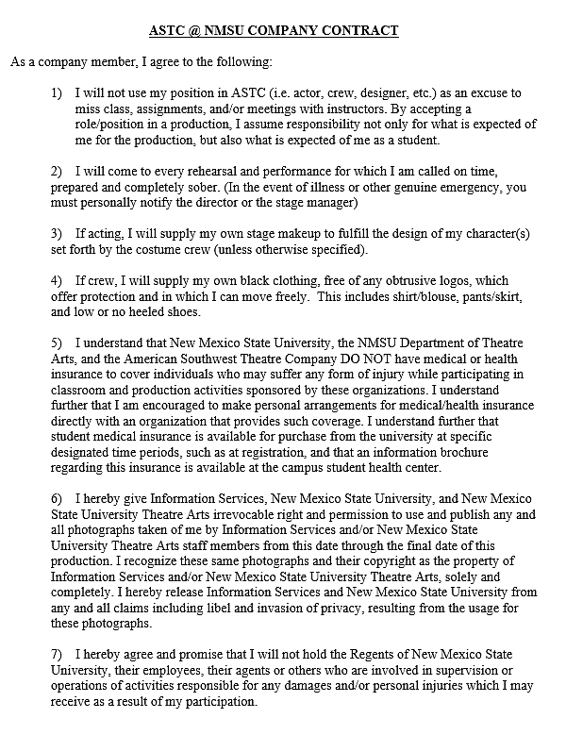
Email: __________________________________________
First Name: ___________________________________
Last Name: ___________________________________
Phone # ___________________________________
Age: _________________

Name & Phone # of emergency contact: ___________________________________
___________________________________

Physician’s Name & Phone # ___________________________________
___________________________________

Current Medications and Dosage (i.e. 10mg, etc) ___________________________________

Allergies to any medications, foods, and/or substances ___________________________________

Any additional medical or emergency information ___________________________________

Electronic Signature* (full name): ___________________________________
Date: ___________________________________

*by typing your full name above, you hereby agree to accept the terms of this document with your electronic signature

